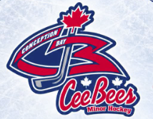
September 9th, 2026

To Whom it may concern,
Cee Bees Minor Hockey is a not for profit minor sports association that depends solely on volunteers to help implement, coordinate and manage our programs, games and tournaments for children of the Conception Bay Area. Without important dedicated volunteers, Cee Bees Minor Hockey would not be able to run a successful program.
As part of the screening process of Cee Bees Minor Hockey and Hockey Newfoundland all volunteers need to submit a letter of conduct and vulnerable sector check to the local Association and Provincial Branch.
Please accept this letter as verification that the above applicant is a volunteer with the Cee Bees Minor Hockey Program.
If you have any questions or concerns, please feel free to contact me

Yours in Hockey,
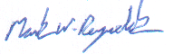
Mark Reynolds
President
Cee Bees Minor Hockey
709-683-6811
ceebeespresident@gmail.com

