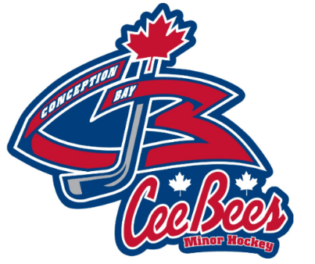
2020-2021 Memo
In an effort to work within the guidelines set out by Hockey NL, CMO and DCCC, CeeBees Minor hockey have a plan to start the 2020-2021 season.
The 2020/2021 season will commence with skills and drills only. A phased progression through skills and drills, modified games format respecting physical distancing will occur, and potentially a return to familiar 5-on-5 hockey later in the season.
The Return To Play involves the progression through 5 phases. Each association and league is expected to start at Phase 1, and move through the other phases over time. There are no set dates or timeframes established for the transition through the 5 phases, however it is expected that a 14 day minimum at each phase will be required for all participants to adjust to the increased responsibility for physical distancing and proper hygiene associated with each phase. Progression from phase 1 to 5 will only be approved by Hockey NL when direction from the CMO permits. While we are focused on progressing through the various phases as the season moves forward, the presence of COVID-19 in the community might dictate otherwise. It is possible at some point that associations and leagues may have to move back to a previous phase to ensure the safety of all participants.
Start Date: CeeBees Minor have a return to play on ice on September 21, 2020.
Registration Dates: Thursday September 3rd and Tuesday September 8th at DCCC, 6:00 – 8:00 pm. Please continue to check the website for additional registration information. Due to the necessary scheduling and Covid restrictions, players must be registered one (1) week before they are allowed on the ice.
Cost: Each division will be provided 30 hours, insurance cost included for $400. To be allowed on the ice, players must have 75% of the registration fee ($300) paid.
Outstanding fees: Any players with outstanding fees from the 2019-2020 season will not be permitted on the ice.
2019-2020 Credit: Due to the 2019-2020 season being cut short due to COVID-19, all players with registration paid in full last season will receive credits to be used for the 2020-2021 season which will be based on the number of hours not used. To find out whether you have 2019-2020 credits contact Rob Button at robbutton@hotmail.com.
Fundraising: With Covid-19 restrictions, CeeBees are not sure what fundraising initiatives will be permitted. To check to see if you have fundraising credits, please email Rob Button at robbutton@hotmail.com. CeeBees will post if and when fundraising initiatives will be undertaken.
All-star: To be eligible to tryout for all-star rep teams when HNL allows a move to phase 5, CeeBees players must have registered and attended the HL sessions.
Programming: As we are uncertain when a return to all-star hockey will occur, we will continue with a House League program only. If a move to all-star hockey is delayed, CeeBees will increase the hours (and associated cost) for the HL program.
Scheduling: CeeBees are attempting to plan so that each player gets two on-ice hours per week. Covid restrictions require careful planning and with 25 people (coaches and players) allowed on the ice per hour. Each session will have players assigned, thus absolutely no drop-ins will be permitted.
Stadium Guidelines: Please see the return to play document posted about stadium requirements for all users.
Time frame: All CeeBees sessions will be 1 hour in length. No one is allowed into the stadium until 10 minutes before a session. All players must be exited the stadium 10 minutes after their session. NO ONE IS PERMITTED TO HANG OUT IN THE LOBBY.
Changing Rooms: Two change stations are set up. Players must be dressed when entering the stadium, with the exception of skates. THERE ARE NO SHOWERS AVAILABLE.
Washrooms: Only one washroom on the lower level is open to the public.
Sanitizing Stations: There are 5 sanitizing stations in the stadium. Everyone must use the hand sanitizer upon entering the stadium.
Female HL: If female player registrations warrant CeeBees would like to have two female HL divisions.
Fountains: Players are not to use the fountains at the stadium. Water containers must be brought to the stadium.
Stadium Patrons: For the start of the season, only one guardian will be permitted into the stadium per player.

